The system I intend to create is an arm motion capture rig using two MPU 6050 six axis accelerometer/gyro sensors connected to OpenGL software through an Arduino so as to animate an aperture from sensor data in real time. Using the MPU 6050 (implemented with the GY-521 breakout board) the rig will be able to determine the current world orientation of both the forearm and upper arm and relay that information via USB to a PC based OpenGL program that will animate the data. Included also is a push button at the end of the rig that can be used to indicate grip when needed.

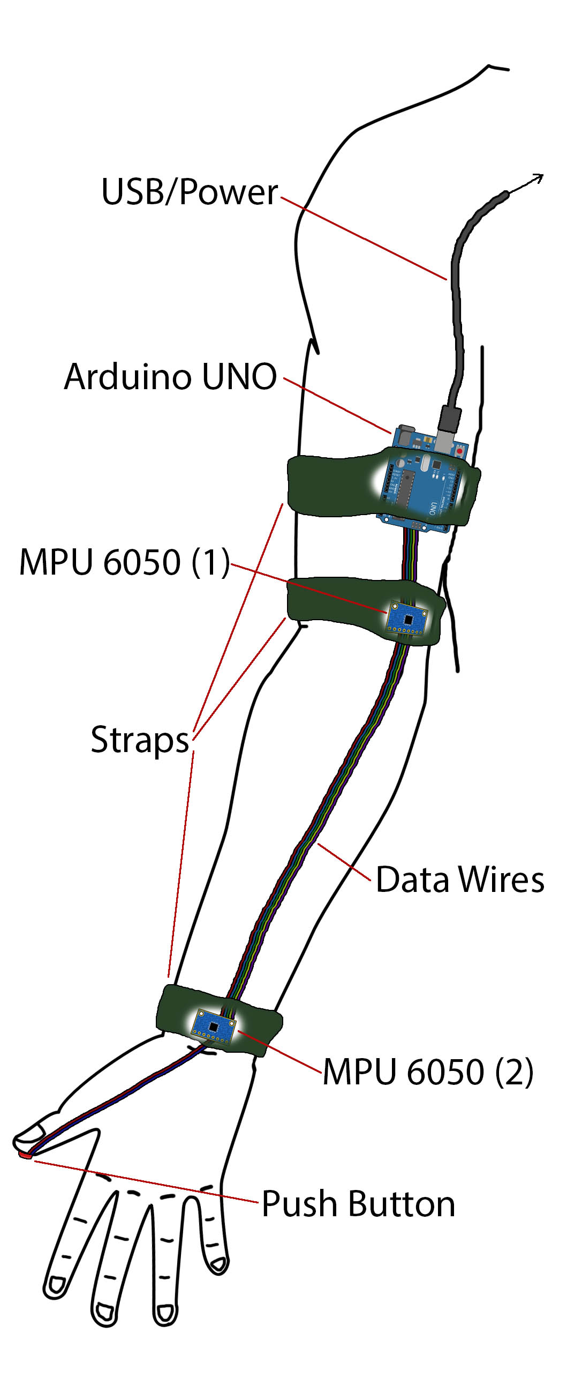

This problem is interesting to me because I have, as a hobby, been making Arduino based projects for years now. This problem if motion capture seems to be a simple and fun way of integrating this course’s material with my own expertise. This problem is especially relevant now due to the rising popularity of VR technology, which this system could easily be integrated into.

I plan to design and construct this rig (shown to the right) and write a demo program using OpenGL that will communicate with the hardware and render the real time data. The program for the rig will at the minimum have an Upper/Forearm linkage with and end effector “gripper”, and the operator will be able to temporarily parent gripped objects to the linkage. If all that goes well, I would like to integrate this input with a rigid body physics simulation of the objects touched. So the demo may end up being a bowling game, or some assembly line mini-game, but whatever it ends up being it will involve as input this arm aperture.

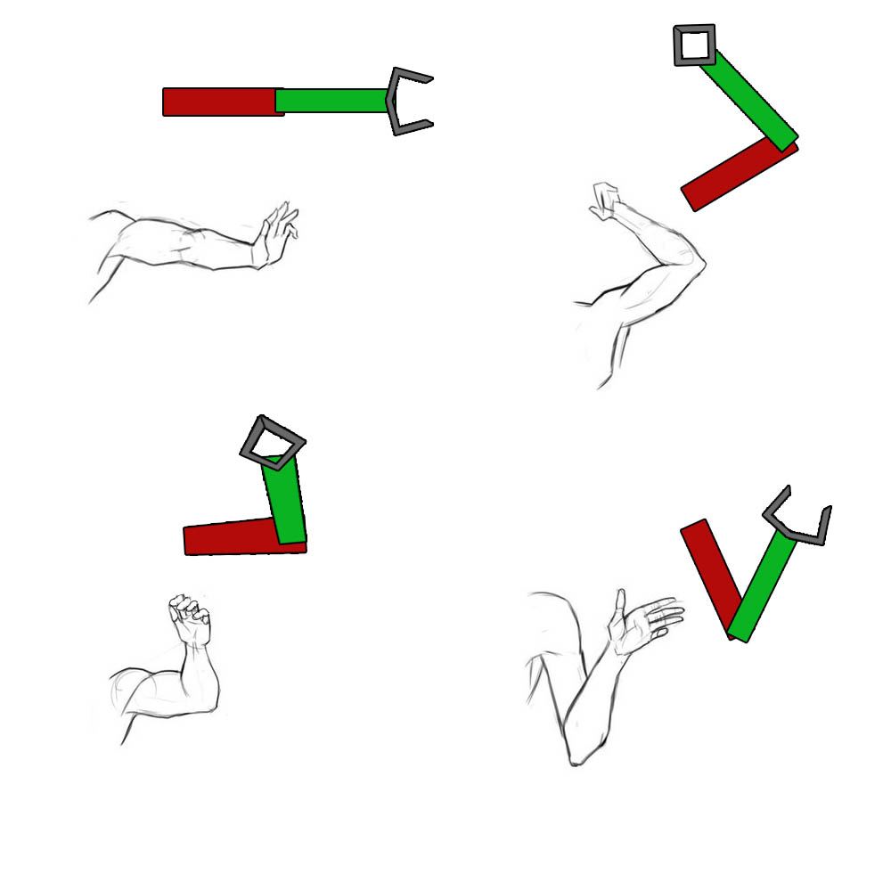

Final Goals:

To have built a working piece of custom hardware that can be used for accurate motion capture.

To make the rig expandable so that more linkages can be added and more complex rigs can be made with little extra development.

To have programed software that can be used to control and get data from such a rig for general purposes, i.e. to make a library for the hardware.

To make a demo that is portable and demonstrates the power of the rig.

Work Breakdown

|  |  |  |
| --- | --- | --- |
| **Job** | **Description** | **Planned Work Days** |
| Breadboard | Make beta version of hardware for testing and prototyping | Oct. 29 |
| Arduino Code | Write embedded code that will send via USB the measurements of the sensors and the button. | Nov. 1 |
| Data Conversion | The raw data is not accurate and error prone, correct and convert it to quaternion | Nov. 1 |
| Interfacing | Read data from the Arduino on the PC end through the USB | Nov. 4-5 |
| Implement | Set up OpenGL scene and use interfaced data to update a rig | Nov. 4-5 |
| Soldering Rig | Determine wire lengths and semi-permanently attach to Arduino | Nov. 11-12 |
| Strapping | Devise a comfortable and stable method of securing hardware to an arm | Nov. 11-12 |
| Enhance | Develop functionality for the end effector interaction with other objects in the scene | Nov. 18-19 |
| Physics | Develop a (simple) rigid body physics simulation that the linkage can interact with | Nov. 25-Dec. 2 |
| Gamify | Use the physics and linkage to make a mini-game or tech demo for presentation | Nov. 25-Dec. 2 |